Stack
- last in, first out or LIFO order
- Collection of items with “last in, first out” retrieval
- Allows insertion and removal of elements only at one end called the top of the stack
- New items are added to the top of the stack
- Items are removed at the top of the stack
- Addition and removal operations are called push and pop

Queue
- Queues store items in a first in, first out or FIFO fashion
- Add items to one end of the queue (the tail)
- Remove items from the other end of the queue (the head)
- Items are removed in the same order in which they have been added

Stacks and Queues: Uses in Computer Science
•Queue
  - Event queue of all events, kept by the Java GUI system
  - Queue of print jobs
•Stack
- Run-time stack that a processor or virtual machine keeps to organize the variables of nested methods

Stacks and Queues in the Java Library
• Class Stack implements the abstract stack data type and the push and pop operations
• Methods of Queue interface in the standard Java library include:
• add to add an element to the tail of the queue
• remove to remove the head of the queue
• peek to get the head element of the queue without removing it
• Queue implementations in the standard library are designed for use with multithreaded programs

Exercise
Why wouldn’t you want to use a stack to manage print jobs?
Answer
Stacks use a “last in, first out” discipline. If you are the first one to submit a print job and lots of people add print jobs before the printer has a chance to deal with your job, they get their printouts first, and you have to wait until all other jobs are completed.

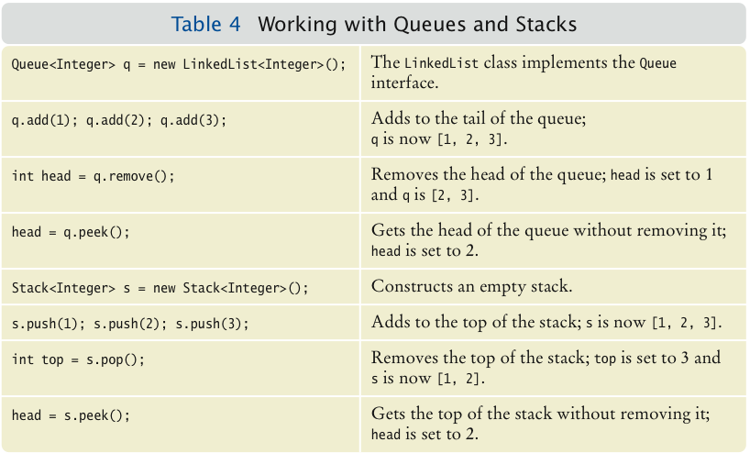
Exercise
Draw a sketch of the abstract queue type
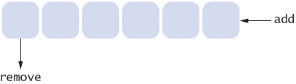

Linked Lists
• A linked list consists of a number of nodes, each of which has a reference to the next node
• Adding and removing elements in the middle of a linked list is efficient
• Visiting the elements of a linked list in sequential order is efficient
• Random access is not efficient

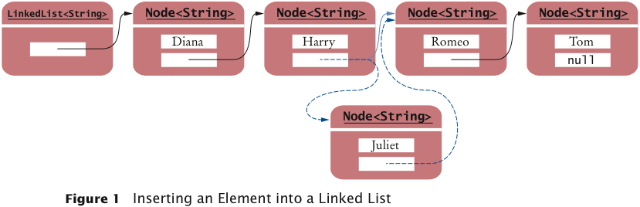
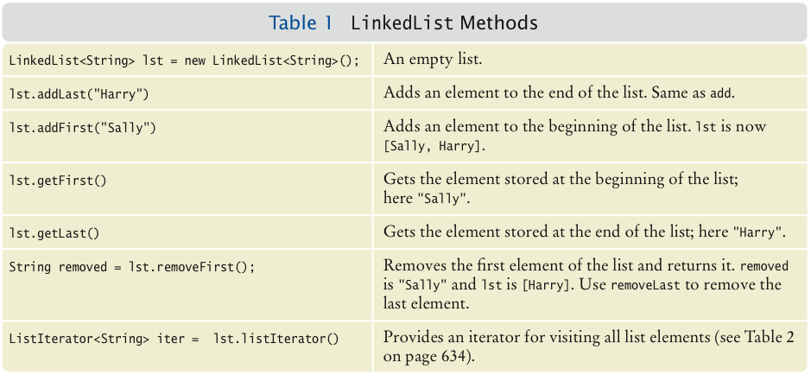
List Iterator
• ListIterator type
• Gives access to elements inside a linked list
• Encapsulates a position anywhere inside the linked list
• Protects the linked list while giving access

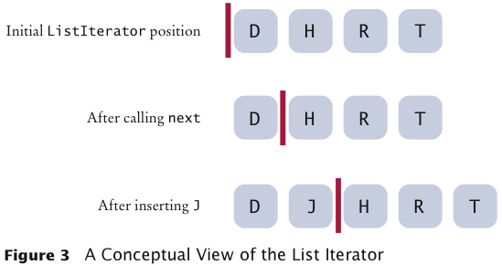

The add method:
  - Adds an object after the iterator
  - Moves the iterator position past the new element:

The remove method
  - Removes and returns the object that was returned by the last call to next or previous
//Remove all names that fulfill a certain condition
while (iterator.hasNext())
{
String name = iterator.next();
if (name fulfills condition)
iterator.remove();
}

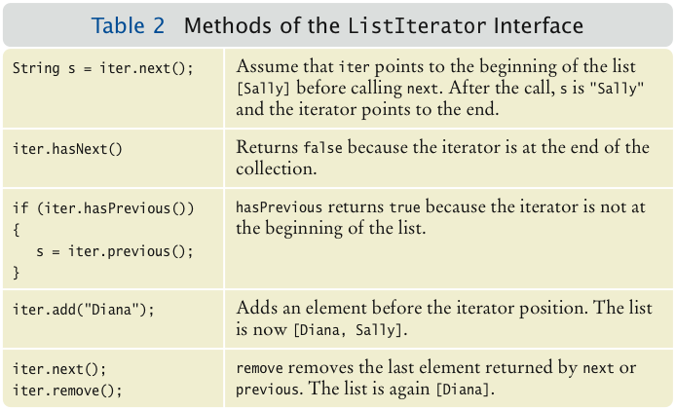

Exercise
Do linked lists take more storage space than arrays of the same size?
Answer
Yes, for two reasons. You need to store the node references, and each node is a separate object. (There is a fixed overhead to store each object in the virtual machine.)

Exercise:
Why don’t we need iterators with arrays?
Answer:
An integer index can be used to access any array location.

Example
import java.util.*;
public class ListTester{
public static void main(String[] args){
LinkedList<String> staff = new LinkedList<String>();
staff.addLast("Diana");
staff.addLast("Harry");
staff.addLast("Romeo");
staff.addLast("Tom");
// | in the comments indicates the iterator position

ListIterator<String> iterator = staff.listIterator(); // |DHRT
iterator.next(); // D|HRT
while (iterator.hasNext())
{
System.out.print(iterator.next()+" ");
}

iterator.next(); // DH|RT
// Add more elements after second element
iterator.add("Juliet"); // DHJ|RT
iterator.add("Nina"); // DHJN|RT
iterator.next(); // DHJNR|T
// Remove last traversed element
iterator.remove(); // DHJN|T
// Print all elements
for (String name : staff)
System.out.print(name + " ");
System.out.println();
}
}

Program Run:
Diana Harry Juliet Nina Tom

There are two ways of looking at a linked list
  - To think of the concrete implementation of such a list
    - Sequence of node objects with links between them
  - Think of the abstract concept of the linked list
    - Ordered sequence of data items that can be traversed with an iterator

There are two ways of looking at an array list
- Concrete implementation: A partially filled array of object references
- Abstract view: Ordered sequence of data items, each of which can be accessed by an integer index

Abstract Data Types
- ArrayList: Combines the interfaces of an array and a list
- Both ArrayList and LinkedList implement an interface called List
  - List defines operations for random access and for sequential access

Abstract list
  - Ordered sequence of items that can be traversed sequentially
  - Allows for insertion and removal of elements at any position

Abstract array
  - Ordered sequence of items with random access via an integer index

Exercise
What is the advantage of viewing a type abstractly?
Answer
You can focus on the essential characteristics of the data type without being distracted by implementation details.

Exercise
How much slower is the binary search algorithm for a linked list compared to the linear search algorithm?
Answer
To locate the middle element takes n / 2 steps. To locate the middle of the subinterval to the left or right takes another n/4 steps. The next lookup takes n / 8 steps. Thus, we expect almost n steps to locate an element. At this point, you are better off just making a linear search that, on average, takes n / 2 steps.

Set
- Unordered collection of distinct elements
- Elements can be added, located, and removed
- Sets don’t have duplicates

Operations
- Adding an element
  - Adding an element has no effect if the element is already in the set
- Removing an element
  - Attempting to remove an element that isn’t in the set is silently ignored
- Containment testing (Does the set contain a given object?)
- Listing all elements (in arbitrary order)

We could use a linked list to implement a set
  - Adding, removing, and containment testing would be relatively slow
- There are data structures that can handle these operations much more quickly
  - Hash tables
  - Trees
- Standard Java library provides set implementations based on both data structures
  - HashSet
  - TreeSet
- Both of these data structures implement the Set interface
- As a rule of thumb, use a hash set unless you want to visit the set elements in sorted order

Iterator
- Use an iterator to visit all elements in a set
- A set iterator does not visit the elements in the order in which they were inserted
- An element cannot be added to a set at an iterator position
- A set element can be removed at an iterator position

Exercise
Arrays and lists remember the order in which you added elements; sets do not. Why would you want to use a set instead of an array or list?
Answer
Efficient set implementations can quickly test whether a given element is a member of the set.

Exercise
Why are set iterators different from list iterators?
Answer:
Sets do not have an ordering, so it doesn’t make sense to add an element at a particular iterator position, or to traverse a set backwards.

Exercise
When would you choose a tree set over a hash set?
Answer
When it is desirable to visit the set elements in sorted order.

Example
- Read in all words from a dictionary ﬁle that contains correctly spelled words and place them into a set
- Read all words from a document into a second set
- Print all words from that set that are not in the dictionary set — potential misspellings/

import java.util.*;
import java.io.*;
public class SpellCheck{
public static void main(String[] args) throws FileNotFoundException {
// Read the dictionary and the document
Set<String> dictionaryWords = readWords("words.txt");
Set<String> documentWords = readWords("file.txt");
// Print all words that are in the document but not the dictionary
for (String word : documentWords){
if (!dictionaryWords.contains(word))
System.out.println(word);
}
}
/** Reads all words from a file.
*/
public static Set<String> readWords(String filename) throws FileNotFoundException{
Set<String> words = new HashSet<String>();
Scanner in = new Scanner(new File(filename));
// Use any characters other than a-z or A-Z as delimiters
in.useDelimiter(" ");
while (in.hasNext())
words.add(in.next().toLowerCase());
return words;
}
}

Example2
import java.util.*;
/** This program demonstrates the hash set class.
*/
public class HashSetDemo {
public static void main(String[] args){
Set<String> names = new HashSet<String> (10);
names.add("Harry");
names.add("Sue");
names.add("Nina");
names.add("Susannah");
names.add("Larry");
names.add("Eve");
names.add("Sarah");
names.add("Adam");
names.add("Tony");
names.add("Katherine");
names.add("Juliet");
names.add("Romeo");
names.remove("Romeo");
names.remove("George");
Iterator<String> iter = names.iterator();
while (iter.hasNext())
System.out.println(iter.next());
}
}
Program Run:
Harry
Sue
Nina
Susannah
Larry
Eve
Sarah
Adam
Juliet
Katherine
Tony

Maps
- A map keeps associations between key and value objects
- Mathematically speaking, a map is a function from one set, the key set, to another set, the value set
- Every key in a map has a unique value
- A value may be associated with several keys
- Classes that implement the Map interface
  - HashMap
  - TreeMap
- Both of these data structures implement the Map interface

Example:
import java.awt.Color;
import java.util.*;
public class MapDemo{
public static void main(String[] args) {
Map<String, Color> favoriteColors = new HashMap<String, Color>();
favoriteColors.put("Juliet", Color.BLUE);
favoriteColors.put("Romeo", Color.GREEN);
favoriteColors.put("Adam", Color.RED);
favoriteColors.put("Eve", Color.BLUE);

// Print all keys and values in the map
Set<String> keySet = favoriteColors.keySet();
for (String key : keySet) {
Color value = favoriteColors.get(key);
System.out.println(key + " : " + value);
}
}
}
Program Run:
Romeo : java.awt.Color[r=0,g=255,b=0]
Eve : java.awt.Color[r=0,g=0,b=255]
Adam : java.awt.Color[r=255,g=0,b=0]
Juliet : java.awt.Color[r=0,g=0,b=255]

Exercise
What is the difference between a set and a map?
Answer:
A set stores elements. A map stores associations between keys and values.

Exercise
Why is the collection of the keys of a map a set?
Answer
The ordering does not matter, and you cannot have duplicates.

- Hashing can used to find elements in a data structure quickly without making a linear search
- A hash table can be used to implement sets and maps
- A hash function computes an integer value (called the hash code) from an object
- A good hash function minimizes collisions — identical hash codes for different objects
- To compute the hash code of object x: int h = x.hashCode();

Problems with Simplistic Implementation
- It is not possible to allocate an array that is large enough to hold all possible integer index positions
- It is possible for two different objects to have the same hash code
Solution
- Pick a reasonable array size and reduce the hash codes to fall inside the array
int h = x.hashCode();
if (h < 0) h = -h;
position = h % buckets.length;
- When elements have the same hash code:
  - Use a node sequence to store multiple objects in the same array position
  - These node sequences are called buckets

Algorithm for Finding an Object x in a Hash Table
- Get the index h into the hash table
    - Compute the hash code
    - Reduce it modulo the table size
- Iterate through the elements of the bucket at position h
    - For each element of the bucket, check whether it is equal to x
- If a match is found among the elements of that bucket, then x is in the set
    - Otherwise, x is not in the set

Hashtables
- A hash table can be implemented as an array of buckets
- Buckets are sequences of nodes that hold elements with the same hash code
- If there are few collisions, then adding, locating, and removing hash table elements takes constant time
  - Big-Oh notation: O(1)
- For this algorithm to be effective, the bucket sizes must be small
- The table size should be a prime number larger than the expected number of elements
  - An excess capacity of 30% is typically recommended

Adding an element: Simple extension of the algorithm for finding an object
  - Compute the hash code to locate the bucket in which the element should be inserted
  - Try finding the object in that bucket
  - If it is already present, do nothing; otherwise, insert it

Removing an element is equally simple
- Compute the hash code to locate the bucket in which the element should be inserted
- Try finding the object in that bucket
- If it is present, remove it; otherwise, do nothing

Exercise
If a hash function returns 0 for all values, will the HashSet work correctly?
Answer
Yes, the hash set will work correctly. All elements will be inserted into a single bucket.

Exercise
What does the hasNext method of the HashSetIterator do when it has reached the end of a bucket?
Answer
It locates the next bucket in the bucket array and points to its first element.

Computing Hash Codes
- A hash function computes an integer hash code from an object
- Choose a hash function so that different objects are likely to have different hash codes.
- Bad choice for hash function for a string
  - Adding the unicode values of the characters in the string:
int h = 0;
for (int i = 0; i < s.length(); i++)
h = h + s.charAt(i);

  - Because permutations ("eat" and "tea") would have the same hash code
- Hash function for a string s from standard library
final int HASH_MULTIPLIER = 31;
int h = 0;
for (int i = 0; i < s.length(); i++)
h = HASH_MULTIPLIER * h + s.charAt(i)

- For example, the hash code of "eat" is
31 * (31 * 'e' + 'a') + 't' = 100184

- The hash code of "tea" is quite different, namely
31 * (31 * 't' + 'e') + 'a' = 114704

Binary search trees
- Binary search trees allow for fast insertion and removal of elements
- They are specially designed for fast searching
- All nodes in a binary search tree fulfill the property that:
  - Descendants to the left have smaller data values than the node data value
  - Descendants to the right have larger data values than the node data value

A binary tree consists of two nodes, each of which has two child nodes

Balanced tree: each node has approximately as many descendants on the left as on the right
- If a binary search tree is balanced, then adding an element takes O(log(n)) time
- If the tree is unbalanced, insertion can be slow
  - Perhaps as slow as insertion into a linked list
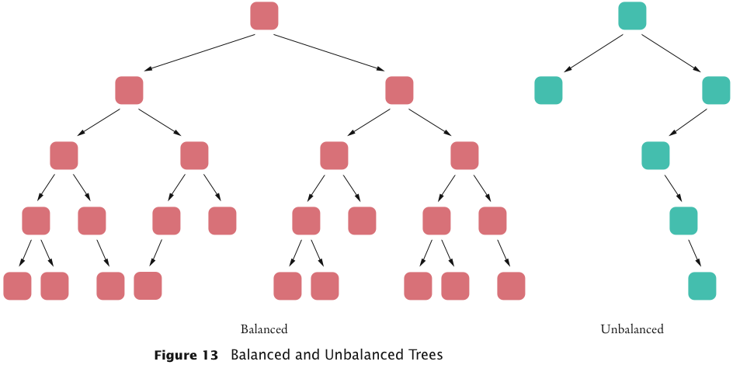
Exercise
What is the difference between a tree, a binary tree, and a balanced binary tree?
Answer
In a tree, each node can have any number of children. In a binary tree, a node has at most two children. In a balanced binary tree, all nodes have approximately as many descendants to the left as to the right.

Binary Tree Traversal
- Print the tree elements in sorted order:
  - Print the left subtree
  - Print the data
  - Print the right subtree

Tree traversal schemes include
- Preorder traversal
- Inorder traversal
- Postorder traversal

Preorder Tree traversal
- Visit the root
- Visit the left subtree
- Visit the right subtree

Inorder Tree traversal
- Visit the left subtree
- Visit the root
- Visit the right subtree

Postorder Tree traversal
- Visit the left subtree
- Visit the right subtree
- Visit the root

Example
{5,2,3,7,1,10,6}

BST
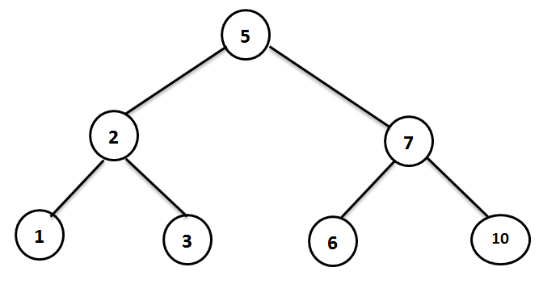
PreOrder root,left subtree , right subtree
[ 5, 2, 1, 3, 7, 6, 10 ]

InOrder Left subtree, root , right subtree
[1 , 2 , 3 , 5 , 6 , 7 , 10 ]

PostOrderLeft subtree, right subtree, root
[1 , 3, 2 , 6 , 10, 7 , 5 ]

Remove items from BST

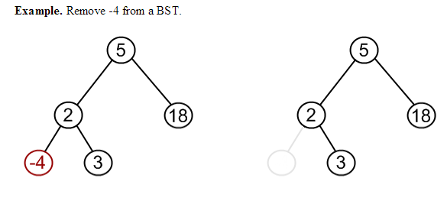

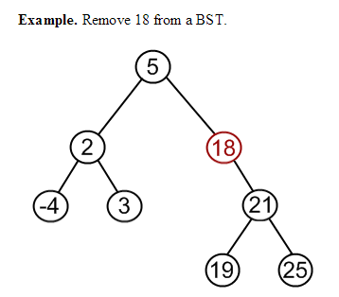
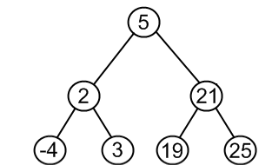

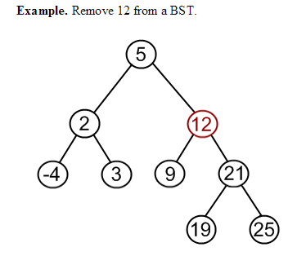
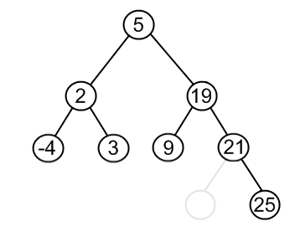
A priority queue
- collects elements, each of which has a priority
- Example: Collection of work requests, some of which may be more urgent than others
- When removing an element, element with highest priority is retrieved
  - Customary to give low values to high priorities, with priority 1 denoting the highest priority
- Standard Java library supplies a PriorityQueue class
- A data structure called heap is very suitable for implementing priority queues
Consider this sample code:
PriorityQueue<WorkOrder> q =new PriorityQueue<WorkOrder>;
q.add(new WorkOrder(3, "Shampoo carpets"));
q.add(new WorkOrder(1, "Fix overflowing sink"));
q.add(new WorkOrder(2, "Order cleaning supplies"));

- When calling q.remove() for the first time, the work order with priority 1 is removed
- Next call to q.remove() removes the order with priority 2

Heaps
- A heap (or, a min-heap) is a binary tree with two special properties
  - It is almost complete
    - All nodes are filled in, except the last level may have some nodes missing toward the right
  - The tree fulfills the heap property
    - All nodes store values that are at most as large as the values stored in their descendants
- Heap property ensures that the smallest element is stored in the root

Differences of a Heap with a Binary Search Tree
- The shape of a heap is very regular
  - Binary search trees can have arbitrary shapes
- In a heap, the left and right subtrees both store elements that are larger than the root element
  - In a binary search tree, smaller elements are stored in the left subtree and larger elements are stored in the right subtree

Heap Efficiency
- Insertion and removal operations visit at most h nodes
- h: Height of the tree
- insertion and removal operations take O(log(n)) steps
- Heap’s regular layout makes it possible to store heap nodes efficiently in an array

Exercise
The software that controls the events in a user interface keeps the events in a data structure. Whenever an event such as a mouse move or repaint request occurs, the event is added. Events are retrieved according to their importance. What abstract data type is appropriate for this application?
Answer
A priority queue is appropriate because we want to get the important events first, even if they have been inserted later.

Draw heap by this array?
[null,4,5,8,11,9,10]
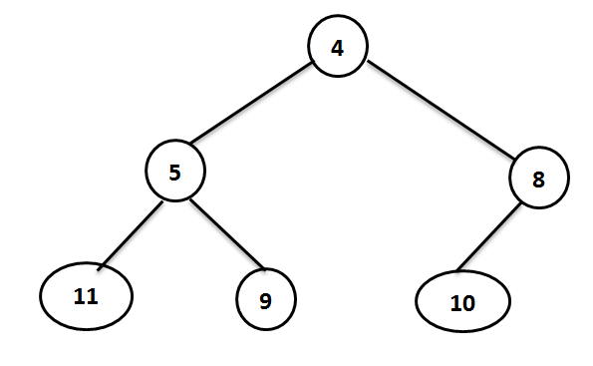

Inserting
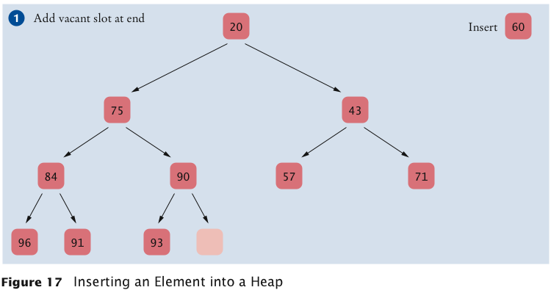
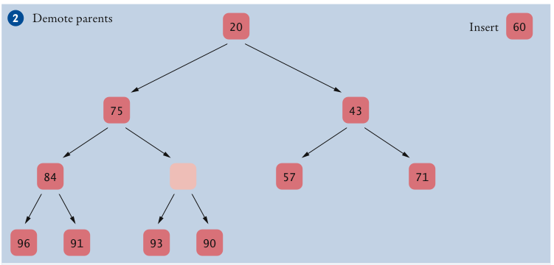
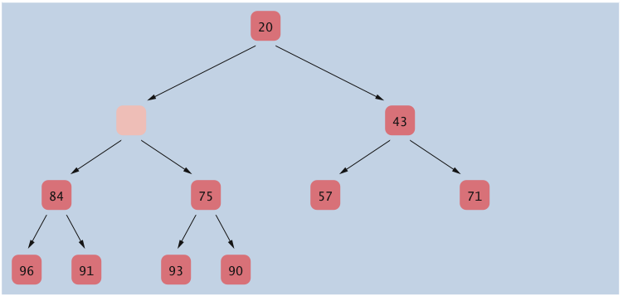
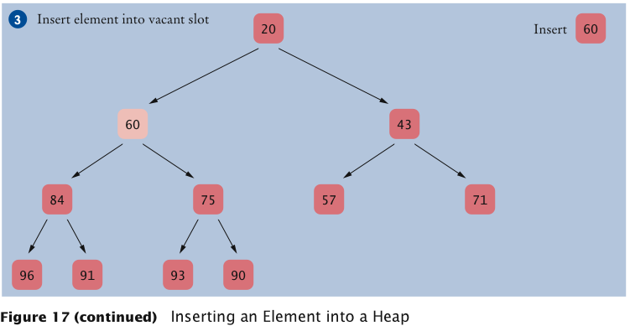

remove process
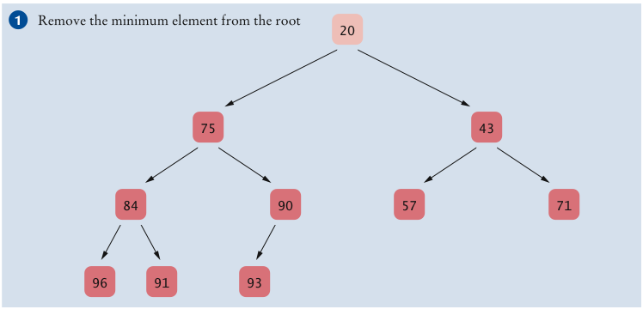
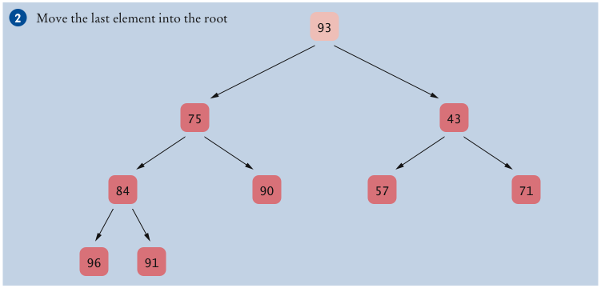
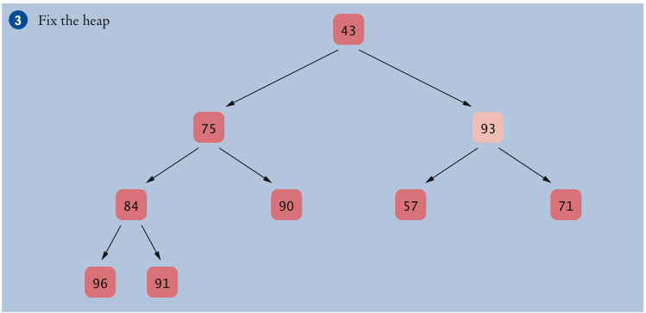
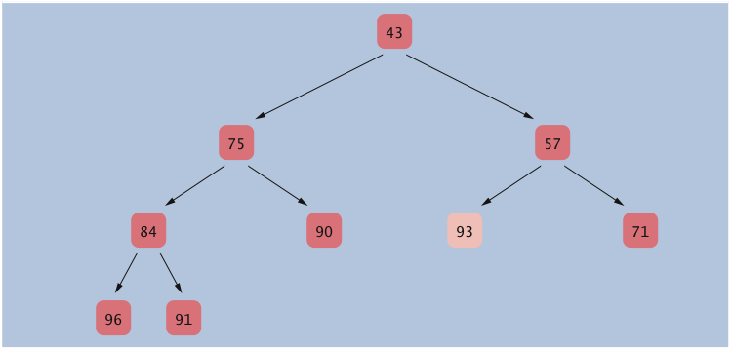
Heapsort algorithm
- Based on inserting elements into a heap and removing them in sorted order
- This algorithm is an O(n log(n)) algorithm:
  - Each insertion and removal is O(log(n))
  - These steps are repeated n times, once for each element in the sequence that is to be sorted
Exercise
Which algorithm requires less storage, heapsort or mergesort?
Answer
Heapsort requires less storage because it doesn’t need an auxiliary array.

